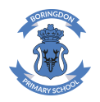
Dear Parents,
Your child now confidently knows all of Read Write Inc’s Set 1 Sounds and is independently blending and therefore your child has now changed Phonics groups and will be in ‘Green Group’. In this Read Write Inc. group children will continue to consolidate their knowledge of Set 1 sounds and they will also be learning new Set 2 sounds which are, ay, ee, igh, ow, oo, ar, or, air, ir, ou, oy. They will also be working on ‘Green Books’. In this group they will be working on a range of writing tasks related to these books. There are 12 Set 2 ‘speed sounds’ that are made up of two or three letters which represent just one sound, e.g. ay as in play, ee as in tree and igh as in high. These are also known as ‘special friends’. When your daughter/son sees these ‘special friends’ in a word, they must say just one sound for these letters.

When your daughter/son learns their Set 2 sounds in school they will learn:
• the letters that represent a speed sound e.g. ‘ay’
• a simple picture prompt linked to the ‘speed sound’ and a short phrase to say e.g. ‘may I play’.
• and an action that will help them to remember the phrase and sound (videos of these can be found on the school website under ‘Reading’ -> ‘Understanding Phonics’ -> ‘Set 2 Sounds’).

Please note: Your child will bring home a ‘Book Bag book’ on Day 1 and a Black and White Ditty Book on Day 3. The colour ‘Book Bag Books’ will be taken out and changed on Day 1 and the Black and White ‘Book Bag Books’ will then come out on Day 3 and the children will receive a new one. Please make sure the books are in their bag every day.
We are so delighted with the amazing progress they have already made!
Kind regards,
The Foundation Team

Set 2 Sounds and Phrases
ay: may I play ee: what can you see | ay: may I play ee: what can you see
igh: fly high ow: blow the snow | igh: fly high ow: blow the snow
oo: poo at the zoo oo: look at the book | oo: poo at the zoo oo: look at the book
ar: start the car or: shut the door | ar: start the car or: shut the door
air: that’s not fair ir: whirl and twirl | air: that’s not fair ir: whirl and twirl
ou: shout it out oy: toy for a boy | ou: shout it out oy: toy for a boy

How to read the ‘Green Books’
Step 1- Consonants and vowels:
Your child should point to each sound and say it in and out of order. They should say the letter sound and not the letter name.

Step 2- Green words:
Your child should point to each word and read them by saying each sound (Fred talk) and blending the sounds together. For example, they would say c-a-t and then say cat. If your child is unfamiliar with the meaning of a word, please discuss the definition with them.

Step 3– Red Words:
Your child should point to each word and read them. Children cannot sound out red words. They need to learn them by sight. The children are currently starting to learn to read red words.

Step 4-Speedy Green Words:
Ask your child to read the words in and out of order clearly and quickly to develop their fluency.

Step 5- Read the Book:
Your child should point at each word and read them, just as they did in step 2 and step 3. Children should segment and blend the words and blend the sounds together to read each one. Children cannot sound out red words. Please ask your child to read the ditty a few times to enable them to become confident with reading.

Step 6- Questions to talk about:
Once your child has read the book there are questions to talk about at the back of the book. Read aloud the questions to your child and ask them to find the answer on the relevant pages. Do not ask your child to read the question.
Don’t forget to sign your child’s reading book every time you have read or shared a book together.

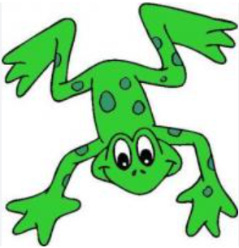Have fun reading!

