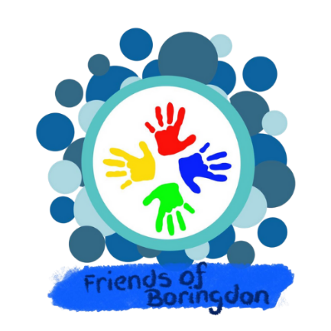

Friends of Boringdon School

Registered Charity No. 1127011

AGM Treasurers Report

April 2023 – April 2024

This report has been prepared by Ruth Didymus, who took over the Treasurer role for Friends of Boringdon, May 2023.

Due to administrative complications with the existing Lloyds bank account, it was agreed to set up a new bank account with Co-operative Bank, July 2023. All existing balances with Lloyds have now been transferred to the Co-operative Bank and all direct payment from the Lloyds account have also been transferred to the Co-Operative Bank.

- Overview of Account

Overview of Account
 | This AGM | Last AGM
 | April 2023 - April 2024 | April 2022 - April 2023
Cash in Bank - Start Date | 2,633.62 | 5,425.79
Paid In | 8,014.76 | 8,229.97
Paid Out | (3,935.60) | (11,022.14)
Cash at Bank - End Date | 6,712.78 | 2,633.62

The balance of £6,712.78 is made up of £6,600.38 in the bank and £112.40 in petty cash, held for cash expenses, as required and event floats.

- Income & Expenditure Breakdown

In the table below, you will be able to see a breakdown of the Income and Expenditure for the year. This has been broken down into various categories. These categories are then broken down, further again in sections 3 – 5 below.

Income & Expenses Breakdown
 | This AGM |  | Last AGM
 | April 2023 - April 2024 |  | April 2022 - April 2023
 | Income Breakdown | Expenses Breakdown | Income Breakdown | Expenses Breakdown
Donations | 1,001.06
Events | 6,987.27 | 1,863.75
Request for Funds |  | 1,718.00
Sundries | 26.43 | 23.69
Insurance/Licence/Fees |  | 330.16
Total | 8,014.76 | 3,935.60 | 8,164.70 | 2,568.35

The volunteers who work to bring the events to the school community aim to keep costs as low as possible, to ensure the maximum profit can be achieved for the school. The generosity of parent supporting these events either by giving their time or by supplying donation for events, is greatly appreciated.

- Donations

Donations
Rotary Club Christmas Door Step Collection | 500.00
Christmas Show Collections | 401.10
Platform & Processing Fees | 99.96
Total | 1,001.06

Total payments taken from the on-line PTA Events system totalled £2,749.50, and this incurred £255.63 of platform and processing fees. However, thanks to the generosity of parents paying these fees, the costs of the PTA Event fees was reduced to £155.67.

- Event Details & Finances

During the year eleven different events have taken place. Detailed below are the financial outcome from each of these events.

Event Details & Finances
 | Income | Expenditure | Profit
Bags for School | 75.00 |  | 75.00
Bingo night | 126.40 | (20.00) | 106.40
Christmas Fair | 1,249.72 | (180.34) | 1,069.38
Frozen Friday | 351.85 | (116.24) | 235.61
Halloween Disco | 882.00 | (147.17) | 734.83
Honey Bees Mufti | 167.00 |  | 167.00
Letter to Santa | 182.50 |  | 182.50
North Pole Story Time | 288.00 | (100.19) | 187.81
Pink Friday | 402.70 | (276.00) | 126.70
Summer Fair | 2,415.60 | (820.46) | 1,595.14
Valentine Disco | 846.50 | (203.35) | 643.15
Total | 6,987.27 | (1,863.75) | 5,123.52

The summer and Christmas fairs were both a huge success and raised a considerable amount of funds. Our thanks go to those who support these events, both parents and staff across the years, without this support these events would not be possible.

The Halloween and Valentine discos also created some happy memories, while raising vital funds.

- Funds requested and Gifts to the School

Request for Funds
Astroturf | 1,050.00
No Parking Signs | 318.00
Years 6 Leavers Video | 250.00
Year 6 Pop up Kitchen | 50.00
Donation to St Lukes (Pink Friday) | 50.00
Total | 1,718.00

The request for funds has been lower this year than in prior year. This is due to request for £12,000 for play equipment in the school. We are over 50% on our way to achieving this target.

The total profit for the year April 2023 – April 2024 was over £4,000.

Ruth Didymus
FOB Treasurer
27th April 2024

